Twitter Text
Social Media Card One
Did you give birth in January or February 2025? Take part in the NHS #MaternitySurvey to help us understand what works well and what needs improvement. We would love to hear your feedback. Find out more: https://www.cqc.org.uk/news/tell-us-what-your-maternity-care-was-you-2025
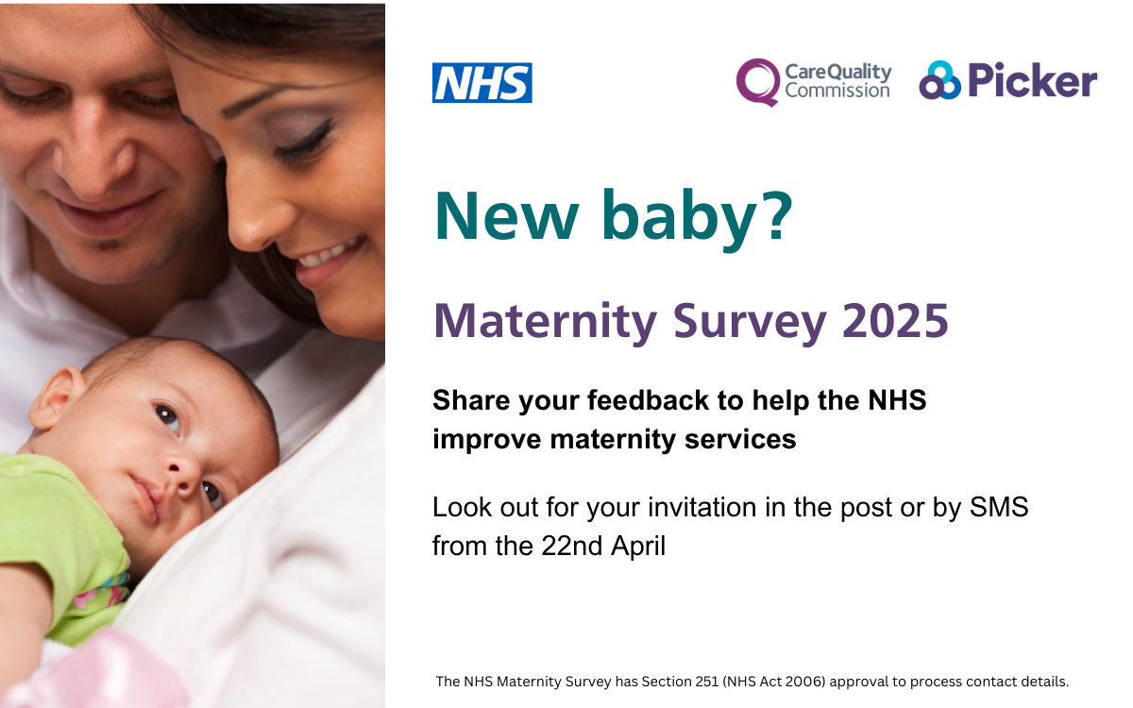

Social Media Card Two
Was your baby born in January or February 2025? You could be invited to take part in our major survey that assesses the quality of maternity services in England. Find out more: https://www.cqc.org.uk/news/tell-us-what-your-maternity-care-was-you-2025
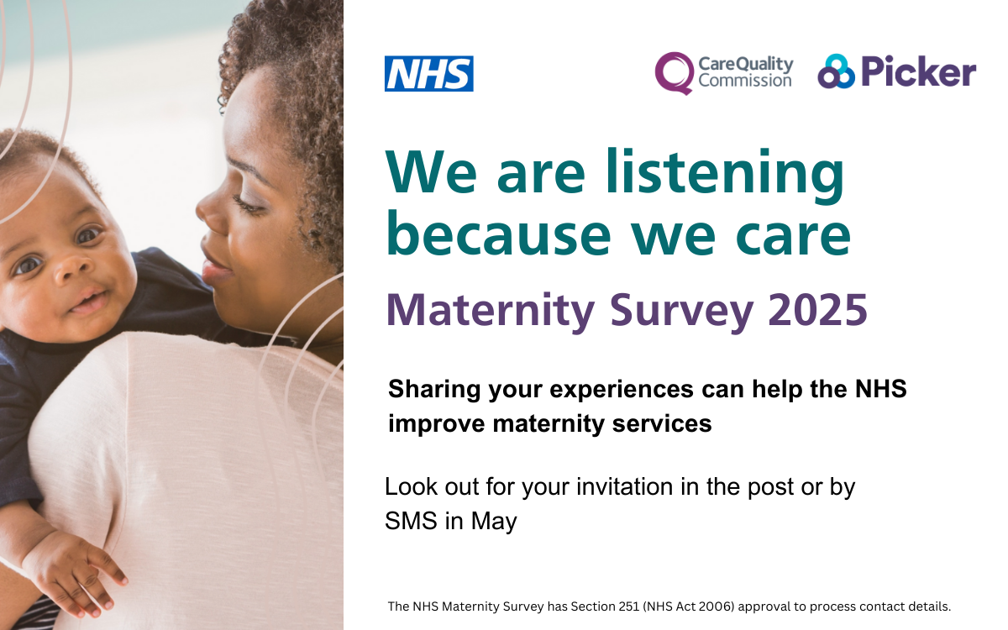

Social Media Card Three
Did you have a baby in January or February 2025? Please tell us about your experiences by completing the #MaternitySurvey. Look out for your invitation in the post or by SMS. Find out more: https://www.cqc.org.uk/news/tell-us-what-your-maternity-care-was-you-2025

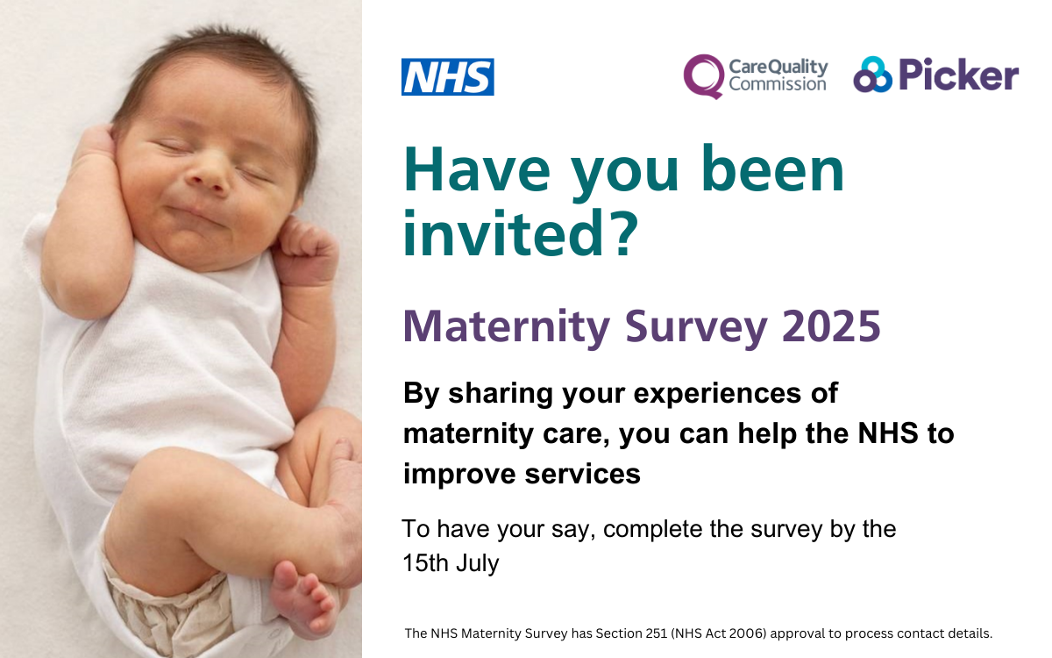

Social Media Card Four
Did you have a baby in January or February 2025? Please complete the #MaternitySurvey and tell us about your experiences of maternity care. Find out more about the survey: https://www.cqc.org.uk/news/tell-us-what-your-maternity-care-was-you-2025

